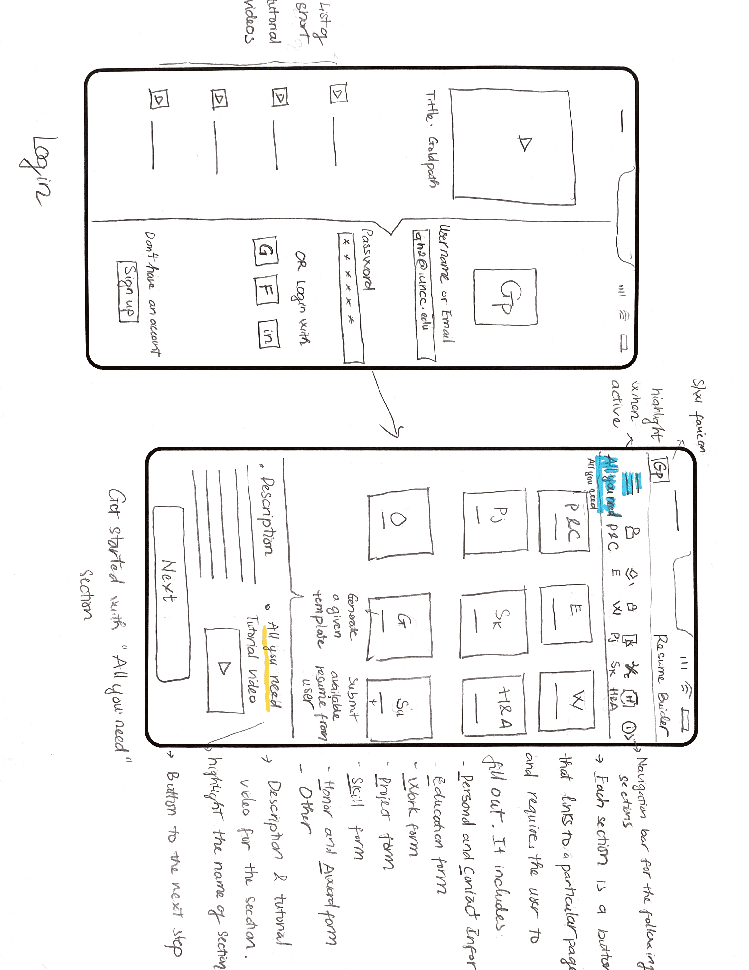

Step 1: Login & Access “All you need” Section

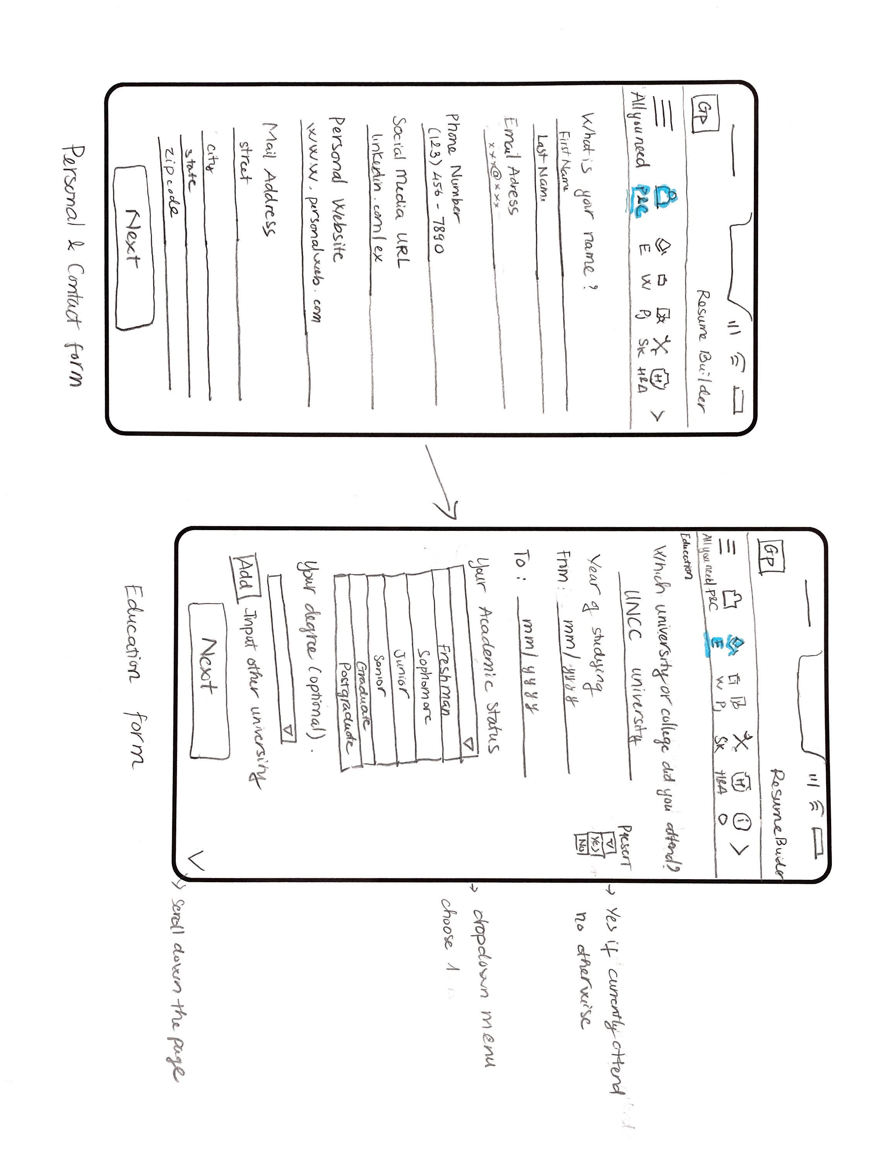

Step 2: Access Personal & Contact Form Section and Education Form section

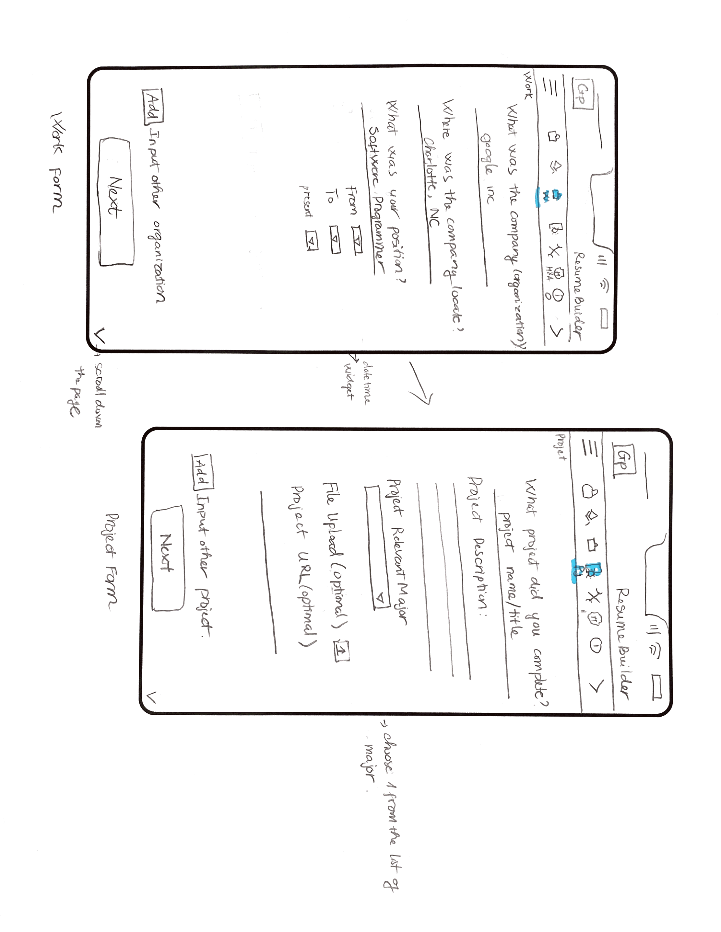

Step 3: Access Work Form Section and Project Form section

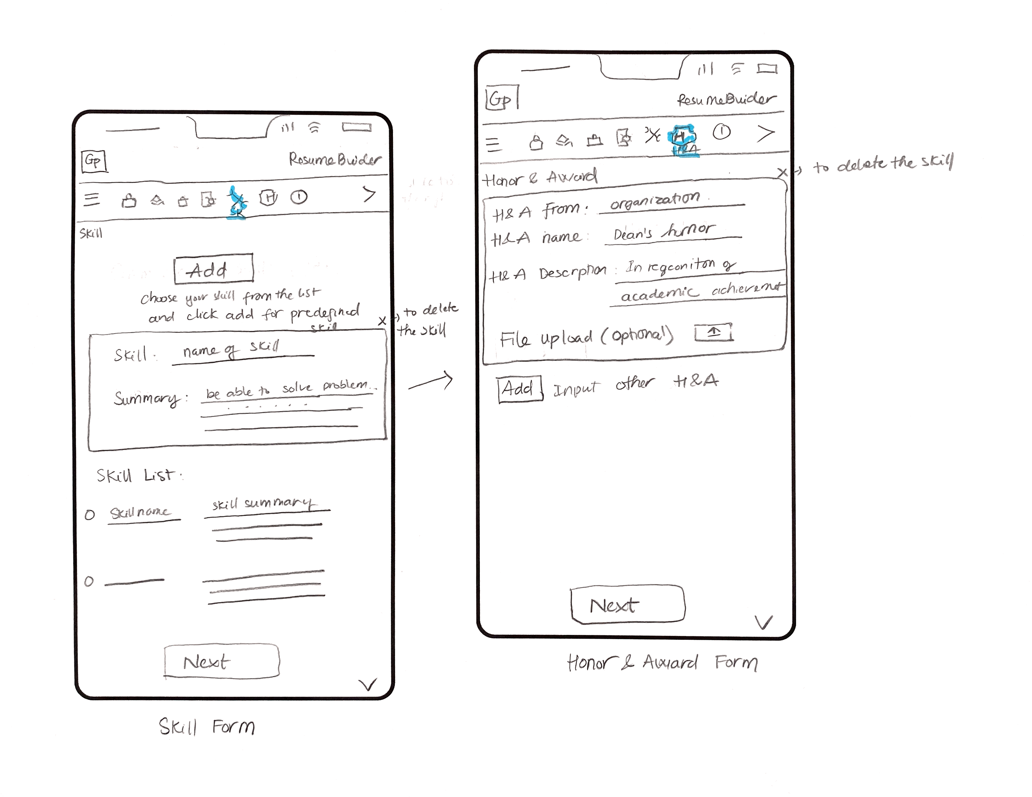

Step 4: Access Skill Form Section and Honor & Award Form section

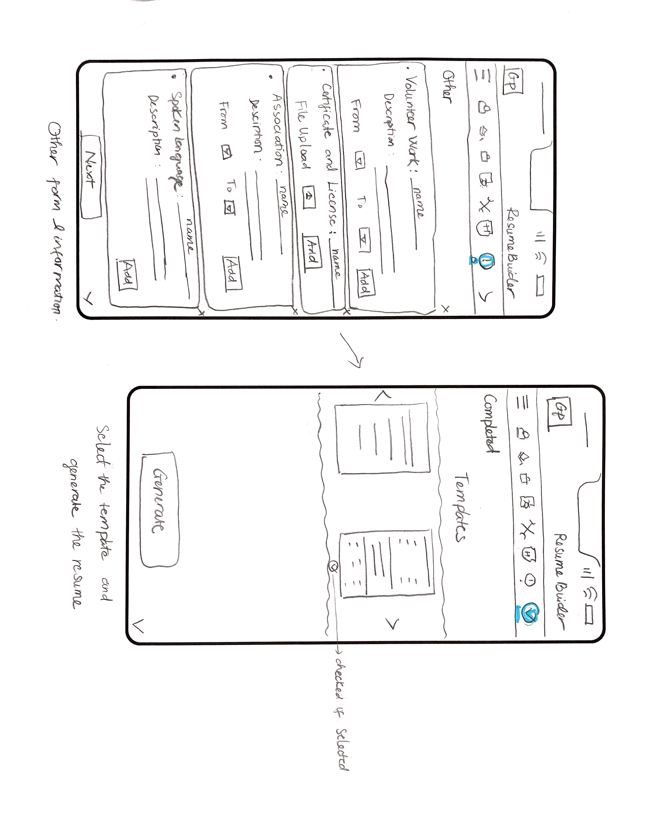

Step 5: Access Other Form Section and Generation Form section